**ASSIGNMENT OF PYTHON SESSION #3**

Q. 1. Find the Armstrong Number between the two numbers which are input by user

(Armstrong number : 153 -> 1*1*1 + 5*5*5 + 3*3*3)

Ans.

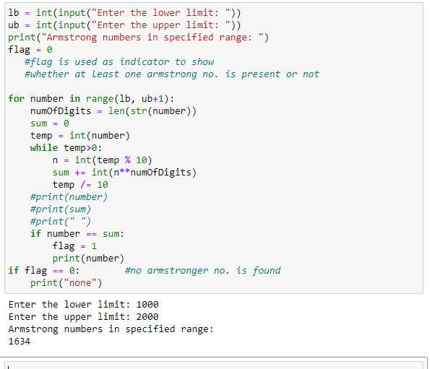

Q. 2. Let’s say you have a string “hello this world @2020!!! ”

Remove the punctuation like [“@!#$%&*()”] from the string

Final output should be without the punctuation

“hello this world 2020”

Ans. 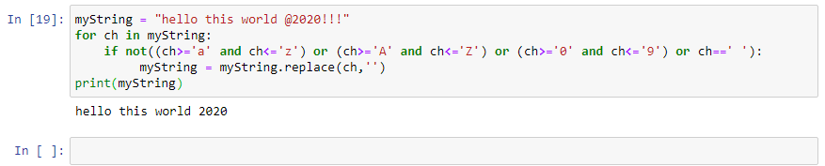

Q. 3. You have a list with words - [“Apple”, “banana”, “cat”, “REGEX”,”apple”]

* Sort words in Alphabetical order
* If you get output, like [Apple, apple, banana]

How has it happened?

Ans. 